RFID Top Ceiling Antenna
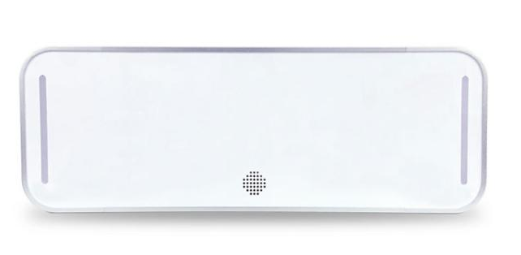

Product introduction:
The ceiling access control antenna is a newly developed high-performance UHF intelligent ceiling-mounted access control. It supports ISO18000-6C protocol, with an optional output power of 10dBm to 30dBm, strong multi-tag recognition capability, strong anti-interference ability, good scalability, and a stylish appearance. It is particularly suitable for shopping malls, clothing stores, shoe and hat stores, and luggage stores.

Characteristics:
- Independent intellectual property design
- Support EPC C1 G2 (ISO18000-6C) protocol
- Output power 10dBm-33dBm adjustable
- Strong multi-tag reading capability, with high-speed tag reading performance
- Simple operation, stylish appearance, easy assembly
- Built-in alarm light and buzzer, sensitive alarm, safe and reliable

Technical Parameters:
Hardware performance
Mainboard | RDIOT_T101_V1.01
Hardware interface
Communication interface | RJ45(10M/100M),RS232（9600-230400bps）,RS485（19200-230400bps）
Optional | WIFI(2.4G), 4G ,POE（802.3af/802.3at）
Protocol | Modbus, HID, HTTP, HTTPS, MQTT, TCP
Instruction lights | Power on（Blue）,alarm（red）
GPIO | 4 inputs, 8 strong drive outputs (each channel can pull current up to 250mA)
Power supply/power consumption
Power supply | Power supply 9-24V;  Standard adapter 12V/2A;  POE power supply (compatible with 802.3af or 802.3at standards)
Consumption |  | Standby 1.76W; operating: 16.2W
Consumption | Single board | operating 0.7W
POE power supply capacity | 100m Category 5e network cable, different models of POE switches have deviations Use 803.at power supply, maximum load capacity 25.1w (11.93V/2.1A)
Environment requests
Operate temperature | -25℃ - +65℃
Stock temperature | -45℃ - +85℃
Humidity | Relative humidity：5-95%
Safety
Power adapts | Air discharge 8KV, contact discharge 6KV; surge immunity: 4KV
Single board | Contact discharge:8KV
Dimension
Size | 200mm X 575mm X 45mm

Outlook dimension
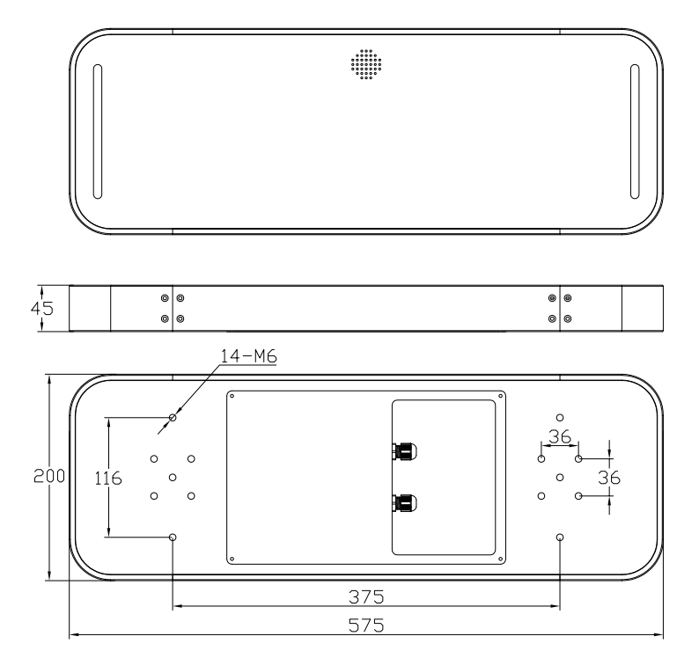
Installations
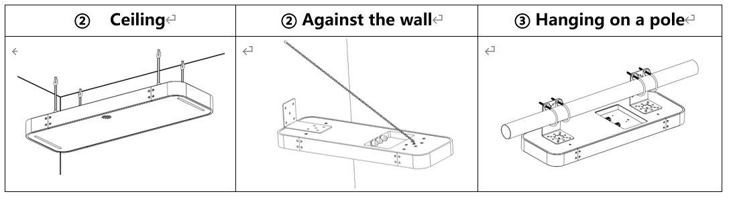Cable connection
- Connect power cable with adapter
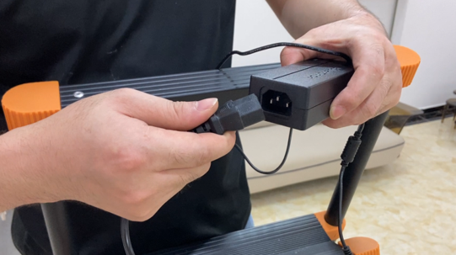
- connect power adapter with antenna power port;
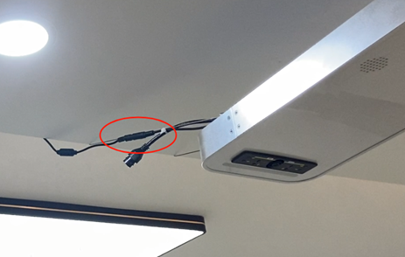
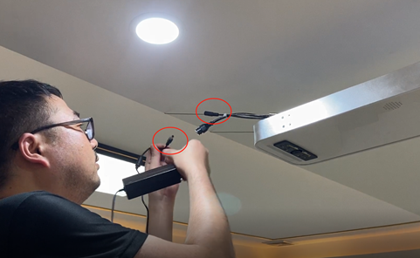
- Connect the network cable to the network cable port of the ceiling antenna and connect the other end to the computer.
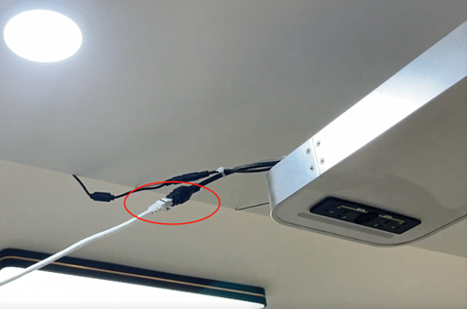

- Connect power plug, then system works；
Test lightings:
Antennas works with blue light, and alarm with red light.
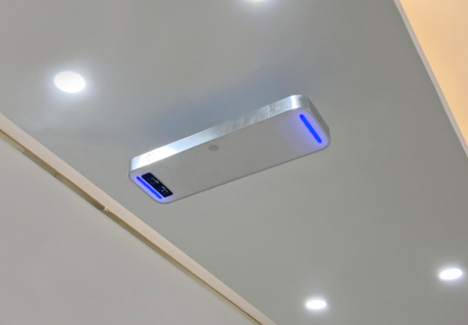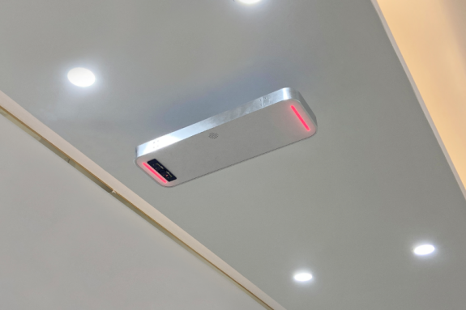
（alarming）
（power on）

